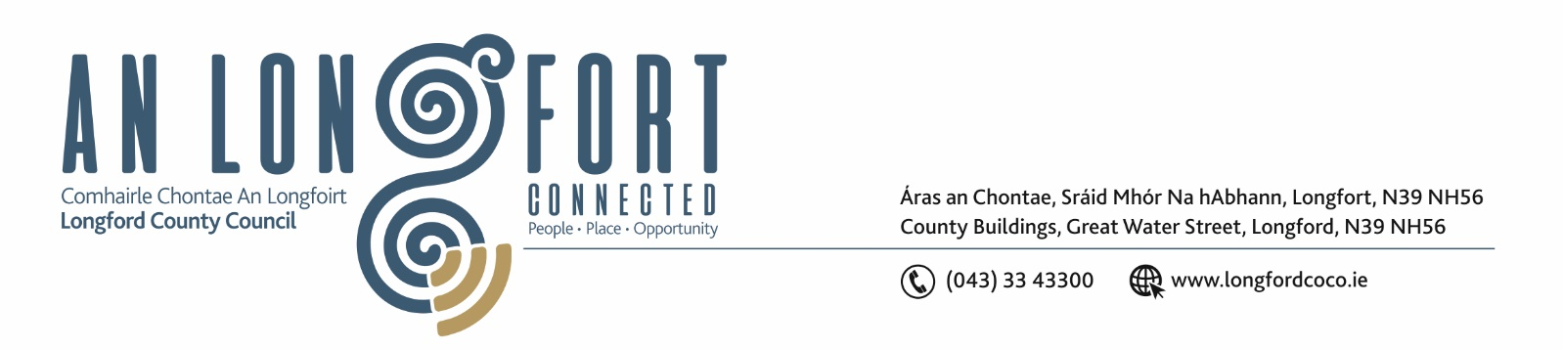

8th June 2021.

To: Each Member of the Joint Policing Committee.

Re: Meeting of the Joint Policing Committee

Dear Member,

I wish to inform you that the next meeting of the Joint Policing Committee will take place
on Monday, 14th June 2021 at 3.00 p.m. to transact business, as set out on the Agenda hereunder.
Due to the ongoing advice from the HSE regarding the COVID-19 Pandemic, the meeting will be held via Microsoft Teams.

Yours sincerely,

___________________
Ann Marie Mc Keon,
Administrative Officer.
AGENDA

1. Confirmation of Minutes of Joint Policing Committee meeting held on the
1st March 2021 - enclosed.

2. Matters arising.

3. Declaration of Interest by Members.
4. Apologies received.

5. Garda Report – to follow.

6. Local Authority Report – enclosed.

